Question 5

Given an IP address range of 192.168.1.0/24, divide the network into 4 subnets.

Task: Manually calculate the new subnet mask and the range of valid IP addresses for each subnet.

Assign IP addresses from these subnets to devices in Cisco Packet Tracer and verify connectivity using ping between them.

Approach

|  |  |  |  |  |  |
| --- | --- | --- | --- | --- | --- |
| VLAN | Subnet | Network Address | First Usable IP | Last Usable IP | Broadcast Address |
| VLAN 10 | 192.168.1.0/26 | 192.168.1.1 | 192.168.1.2 | 192.168.1.62 | 192.168.1.63 |
| VLAN 20 | 192.168.1.64/26 | 192.168.1.65 | 192.168.1.66 | 192.168.1.126 | 192.168.1.127 |
| VLAN 30 | 192.168.1.128/26 | 192.168.1.129 | 192.168.1.130 | 192.168.1.190 | 192.168.1.191 |
| VLAN 40 | 192.168.1.192/26 | 192.168.1.193 | 192.168.1.194 | 192.168.1.254 | 192.168.1.255 |

Now you start with connecting 4 PC’s with switch and connecting it with router. Now assign ip from each subnet to each computer and create virtual network in switch and assign name and ethernet port for it. Add default gateway as first usable IP

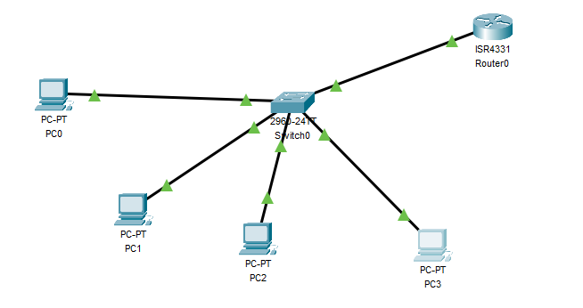

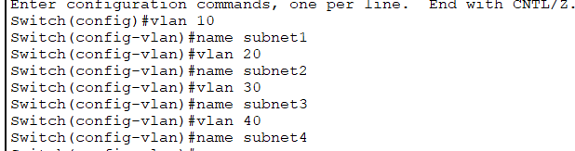

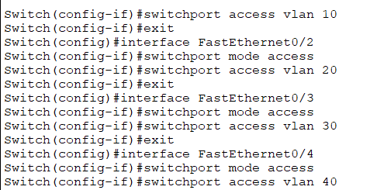



After the setup completed, Now go to router and set ip for each virtual network in GigabitEthernet port

Use first usable ip of each vlan

Interface GigabitEthernet0/0/0.[V_lan Number]

encapsulation dot1Q [V_Lan Number]

ip address [first usable IP] [subnet mask]

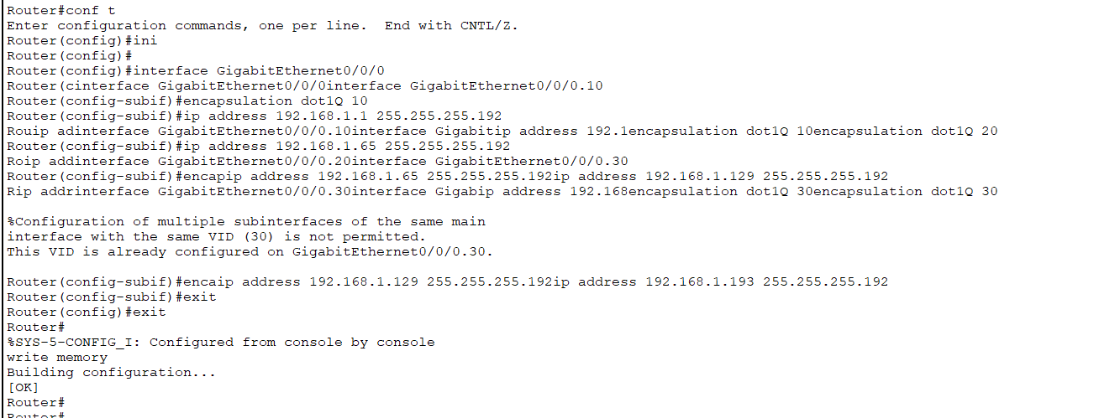

Now try to ping ip on different subnet.

